

PROJECT PROPOSAL
COURSE: SWE3090A
SEMESTER: FALL 2026
INSTRUCTOR: DR. FREDRICK OGORE
NAME: JOY WANJIRU NDUNG’U
ID: 671500
Machine Learning-Assisted Emergency Department Triage and Resource Allocation System
(TRAS)

Contents
Chapter One: Project Introduction and Background 3
1.1 Introduction and Background 3
1.2 Problem Statement 4
1.3 Project Objectives 5
Main Objective 5
Specific Objectives 5
1.4 Justification/Significance 6
Chapter Two: Literature Review 6
2.1 Traditional Triage Systems and Manual Scoring 6
2.2 Machine Learning in Clinical Triage (Global Context) 7
2.3 Machine Learning and Digital Triage in African Healthcare 8
2.4 Operational Capacity and Resource Allocation Systems 8
2.5 Summary of Literature Gaps and Project Contribution 9
Chapter Three: Methodology 10
3.1 Methodology and Justification 10
3.2 Preliminary Investigation 10
3.3 Functional Requirements 11
3.4 Non-Functional Requirements 12
3.5 Design Phase 13
Chapter Four: System Analysis and Design 14
4.1 Data Flow Diagram 14
4.2 Entity Relationship Diagram 15
4.3 Proposed Timeline 17
References 17

Chapter One: Project Introduction and Background

1.1 Introduction and Background
Emergency Departments(EDs) serve as the critical frontline of the healthcare system, operating in very chaotic and high-pressure environments where the medical staff must quickly evaluate patient urgency and decide on the allocations based on the findings. Triage is the foundational process of prioritizing patient care, ensuring that the most critically ill patients receive immediate, life-saving intervention while stable patients are safely queued.
In resource-constrained settings such as the public hospitals in Kenya, the risk of triage is very high. This critical process is often executed under the severe strain of high patient volumes, chronic understaffing, and strictly limited physical infrastructure. A recent 2026 nationwide capacity assessment highlighted significant regional disparities in Kenyan ED infrastructure, proving that the efficient utilization of existing, limited resources is an urgent daily challenge (Ngaruiya et al., 2026).
Currently, triage in these settings is largely governed by manual frameworks such as the World Health Organization's Emergency Triage Assessment and Treatment (ETAT) guidelines, developed primarily for paediatric emergency care, and the South African Triage Scale (SATS), together with local adaptations. ETAT requires nurses to evaluate specific clinical signs, such as obstructed breathing, severe dehydration, or whether the patient is conscious, to manually categorize patients into emergency, priority, or non-urgent queues. As much as the manual systems work, they rely heavily on subjective interpretation by human operators working under extreme stress. This stress inevitably leads to high inter-rater variability, meaning that two different nurses might assign entirely different severity levels to the same patient based on experience, fatigue, or department overcrowding.
Machine learning (ML) models have recently emerged as highly consistent, data-driven tools for predicting patient severity, offering a potential solution to human inconsistency. However, they currently face two major limitations that prevent their clinical adoption. First, many function as algorithmic “black boxes” that fail to explain the reasoning behind their predictions, resulting in a lack of clinical trust from medical professionals who cannot blindly follow an unexplainable AI. Second, existing experimental models successfully predict clinical severity but fail to map those predictions to the actual physical constraints of the hospital. For instance, a recent South African study demonstrated that ML models can effectively classify critically ill children in African clinical settings, validating local feasibility while emphasizing that predictions must remain advisory(Pienaar et al., 2024).
This project bridges the gap by linking transparent ML severity predictions directly to a real-time, rule-based resource allocation dashboard; the system transforms theoretical predictive AI into practical, actionable healthcare logistics.

1.2 Problem Statement
Emergency Departments in Kenyan hospitals lack a unified system that combines transparent severity prediction with real-time resource visibility. This absence creates a failure in patient routing and resource management, driven by these three problems:
- Inter-Rater Variability and Manual Triage Inconsistencies.
The heavy reliance on manual triage frameworks such as ETAT introduces inter-rater variability into the ED, which could be dangerous. Subjective human assessments, made during high-stress and overcrowded shifts, frequently result in triage errors. Under-triage occurs when critically ill patients are misclassified as stable, leading to fatal delays in care. In contrast, over-triage occurs when stable patients are escalated too quickly, wasting highly specialized, limited resources on non-urgent cases. In Kenyan Level 5 hospitals, these inefficiencies directly contribute to a dangerously prolonged Emergency Department Length of Stay (EDLOS), which currently averages 5.6 hours, far exceeding international benchmarks (K'Oremo et al., 2026).
- The Disconnect between Clinical Assessment and Real-Time Resource Allocation.
There is a lack of real-time resource allocation integrated alongside clinical assessment. Currently, a triage nurse or head nurse is required to evaluate a patient’s medical severity while simultaneously attempting to memorize or manually track the availability of physical examination rooms and doctors on duty. This cognitive burden is unsustainable during patient surges. It creates critical bottlenecks where patient routing becomes delayed not by medical necessity, but by administrative confusion and a lack of real-time visibility into the department’s capability.
- The Logistical Isolation of Machine Learning Models.
While machine learning models possess the capability to accurately predict patient severity, their current implementations are completely disconnected from actionable hospital logistics. An ML model that accurately predicts a patient is “Critical” is not that useful to a head nurse if it cannot at the same time identify an available room and a doctor with the appropriate speciality and workload capacity to treat them. Furthermore, because these models often lack explainability features, clinicians cannot trust the predicted severity score.
So, there is a critical need for an integrated decision-support system that standardizes triage severity predictions through transparent machine learning, and dynamically pairs those predictions with real-time hospital resource availability to generate actionable, overridable allocation recommendations.

Project Objectives

Main Objective
To develop and integrate an advisory decision-support system that uses machine learning to predict emergency patient severity from standard triage vitals and links those predictions to a real-time, rule-based dashboard for hospital resource allocation.

Specific Objectives
- To elicit and validate triage requirements and dataset features through literature review and, where accessible, consultation with emergency department nurses, ensuring clinical relevance.
- To develop and integrate an explainable machine learning severity-prediction model that classifies patient urgency while providing transparent reasoning to clinical staff.
- To streamline resource allocation by engineering a deterministic, rule-based algorithm that maps predicted severity to the most appropriate currently available rooms and doctors.
- To facilitate real-time monitoring of ED capacity through a centralized web dashboard, and to evaluate the system's usability and accuracy through scenario-based testing with healthcare professionals or domain-informed evaluators.

Justification/Significance
This project is significant because it can transform emergency department operations without requiring expensive physical infrastructure expansions. While triage bottlenecks are well documented, current technological solutions largely ignore the administrative cognitive overload placed on frontline healthcare workers. By automating the pairing of patients to physical resources, this decision-support system frees triage and head nurses to focus entirely on clinical care rather than facility management.
The project further addresses the primary barrier to AI adoption in healthcare: clinical trust. By prioritizing an explainable machine learning model and actively incorporating operational feedback from practicing emergency nurses, the system ensures that AI serves as a transparent, collaborative tool rather than an autonomous threat.
This research provides a scalable, low-cost software blueprint for optimizing resource-constrained medical environments, directly contributing to reduced patient wait times and improved emergency care delivery in Kenya.

Chapter Two: Literature Review
This literature review evaluates the current state of emergency triage systems, structured across four themes: (1) the limitations of traditional manual triage systems; (2) the global efficacy of Machine Learning (ML) in clinical triage; (3) the specific application of ML and digital triage within African healthcare settings; and (4) the current state of operational resource allocation systems.

2.1 Traditional Triage Systems and Manual Scoring
Historically, emergency triage has relied on standardized, manual scoring frameworks. In low- and middle-income countries, frameworks such as the World Health Organization’s Emergency Triage Assessment and Treatment (ETAT) and the South African Triage Scale (SATS) are widely promoted. Despite their foundational value, these manual systems are subject to considerable operational shortcomings.
A study by Rominski et al. (2014) evaluating the implementation of SATS in an urban teaching hospital in Ghana demonstrated the severe practical difficulties of manual scoring, including inconsistent application by overwhelmed staff and significant inter-rater variability. A 2019 study on the implementation of SATS at Kenyatta National Hospital (KNH) in Nairobi revealed that, before the intervention, KNH, which is the largest public tertiary hospital in East Africa, operated entirely without a standardized accident and emergency triage protocol(Wangara et al., 2019). Decisions were based primarily on clinical "gestalt" (intuition), resulting in inconsistent triage assignments that jeopardized emergent patients. While manual frameworks like SATS offer improvements over having no system at all, their reliance on human calculation under extreme stress inevitably leads to under-triage and over-triage errors.

2.2 Machine Learning in Clinical Triage (Global Context)
To mitigate the subjectivity of manual triage, hospitals globally have increasingly turned to Machine Learning (ML) models. Foundational research by Levin et al. (2018) at Johns Hopkins demonstrated that e-triage systems utilizing machine learning algorithms could differentiate patient clinical outcomes with significantly higher accuracy than the traditional Emergency Severity Index (ESI). Similarly, Raita et al. (2019) compared multiple ML algorithms against standard triage systems, demonstrating that data-driven models could safely predict critical clinical outcomes directly from initial intake vitals.
More recently, a 2025 study conducted in a Thai hospital validated an AI-based emergency triage model across 163,452 real ED visits. The researchers evaluated Logistic Regression, Random Forest, and XGBoost, finding that the XGBoost model dramatically outperformed standard triage scales (achieving an AUROC of 0.917) (Sitthiprawiat et al., 2025). These algorithms have now transitioned from theoretical research to real-world deployment. For example, Hinson et al. (2025) documented the multisite implementation of "TriageGO," an enterprise ML system that provides rapid, risk-based triage tiers to nurses within seconds. However, these systems are almost exclusively designed for high-resource environments seamlessly integrated with comprehensive Electronic Health Records (EHRs).

2.3 Machine Learning and Digital Triage in African Healthcare
Implementing digital triage in African hospitals presents unique infrastructural challenges. A study documenting the implementation of electronic medical records at the Emergency Medicine Department of Muhimbili National Hospital in Tanzania highlighted profound IT constraints, including hardware shortages and staff training barriers (Mashoka et al., 2019).
Despite these barriers, localized digital triage interventions have shown immense promise. Ansermino et al. (2025) conducted an interrupted time series analysis on "Smart Triage," a digital platform implemented in Kenyan facilities (including Mbagathi County Hospital and Kiambu County Referral Hospital) and Uganda. The platform utilizes predictive algorithms to assign risk categories to acutely ill children. While successful in reducing the time to antimicrobial treatment, the system is highly specialized for pediatrics and operates strictly as a clinical risk tool without a resource-allocation engine.
The most critical comparative study for this proposed project is Pienaar et al. (2024), which assessed a proof-of-concept ML model in a South African pediatric ED. The researchers established that ML models can effectively distinguish critically ill patients in African clinical settings, validating the local feasibility of predictive AI. However, the study noted that the models suffered from weaker calibration, meaning the exact probability scores were sometimes overconfident or underconfident. This finding reinforces that while ML is viable in African hospitals, its predictions must remain strictly advisory, necessitating a "human-in-the-loop" approach where nurses retain final decision-making authority. Furthermore, the Pienaar study's model functioned in logistical isolation; it predicted severity but did not assist the nurse in finding an available bed or doctor.

2.4 Operational Capacity and Resource Allocation Systems
In high-resource environments, the logistical challenge of matching patients to resources is increasingly handled by dedicated operational capacity platforms, such as LeanTaaS iQueue and Qventus. These platforms utilize predictive analytics and machine learning to forecast patient demand, coordinate staff schedules, and streamline bed management.
However, deploying these enterprise systems in resource-constrained settings presents severe infrastructural barriers. Studies evaluating digital health implementation in low- and middle-income countries (LMICs) consistently identify fragmented financing, lack of institutional data standardization, and limited technical interoperability as primary obstacles. Enterprise capacity-management solutions rely heavily on continuous, real-time data feeds from comprehensive Electronic Health Record (EHR) systems (e.g., Epic or Cerner) via standard interfaces like FHIR/HL7.
Because many public Level 5 hospitals in Kenya currently operate with fragmented or paper-based record systems, deploying EHR-dependent analytics platforms is technologically prohibitive. Furthermore, these operational platforms focus on macro-level hospital administration, such as forecasting next week's inpatient bed census rather than assisting a triage nurse with immediate, micro-level decisions like assigning a critically ill patient to an open resuscitation room during a busy shift.

2.5 Summary of Literature Gaps and Project Contribution
To the best of the author's knowledge, the reviewed literature reveals a clear operational gap: no study or system was identified that links transparent, locally validated severity prediction to resource allocation without requiring full EHR infrastructure. Traditional manual systems (like ETAT and SATS) are highly subjective and prone to dangerous inter-rater variability under high patient volumes. In contrast, existing enterprise ML systems (like TriageGO and LeanTaaS) are heavily siloed, separating clinical acuity prediction from operational hospital logistics and requiring prohibitive EHR infrastructure. Furthermore, while African-based studies like Pienaar et al. (2024) demonstrate that ML severity prediction is clinically feasible locally, these models fail to translate clinical risk into actionable resource allocation.
This proposed project is designed specifically to operate within this defined literature gap. Rather than relying on the heavy IT infrastructure required by enterprise hospital software, this project proposes a standalone, low-bandwidth decision-support tool tailored for the realities of Kenyan Level 5 hospitals. By taking a transparent ML severity prediction and immediately passing it through a localized, rule-based allocation algorithm, the system connects clinical assessment directly to the physical availability of rooms and doctors. This approach provides an accessible, micro-level triage solution that operationalizes predictive AI without requiring deep EHR integration.

Chapter Three: Methodology

3.1 Methodology and Justification
This project adopts a hybrid development methodology combining Agile Software Development with the CRISP-DM (Cross-Industry Standard Process for Data Mining) framework.
A traditional, linear software development lifecycle (such as the Waterfall model) is unsuitable for this project. Machine learning pipelines are inherently non-linear and empirical; model performance, feature engineering, and hyperparameter tuning require iterative experimentation and continuous evaluation. In contrast, pure data science methodologies lack the software engineering structure required to deliver a robust, deployable web application.
- CRISP-DM structures the machine learning lifecycle; it has six phases: Business/Clinical Understanding, Data Understanding, Data Preparation, Modeling, Evaluation, and Deployment that will ensure that clinical criteria (such as ETAT thresholds) directly inform data preprocessing and that model evaluation prioritizes clinical utility (e.g., optimizing F1-scores) to eliminate false negatives in critical cases.
- Agile Development structures the software engineering lifecycle. Using two-week sprint intervals, core system components such as database schemas, RESTful API endpoints, rule-based algorithms, and user interface screens are built, integrated, and evaluated incrementally. This iterative pace ensures a minimum viable product (MVP) is operational well ahead of final project deployment.
Resources
The system will be built using the following resources:
- The machine learning pipeline uses Python(pandas, scikit-learn, XGBoost, SHAP) trained on a publicly available, anonymized emergency department triahe dataset, supplemented by synthetically generated resource data (rooms, doctors, and patient arrivals) sinc no public dataset covers hospital resources.
- The backend uses Flask, the database and real-time layer user Supabase (PostgresSQL), and the frontend uses React.
- Figma used for wireframes and prototypes, draw.io for system diagram, and Git/GitHub for version control and sprint tracking. All development and testing uses anonymized or synthetic data only.

Preliminary Investigation
To ensure the system addresses authentic clinical challenges and operational constraints, requirements will be gathered through the following proposed techniques:
- Document and Literature Review: A comprehensive secondary investigation forms the foundational requirements of this project. National emergency care assessments in Kenya (e.g., K'Oremo et al., 2026; Ngaruiya et al., 2026), international triage protocols (WHO ETAT, South African Triage Scale), and regional digital health case studies (Ansermino et al., 2025; Pienaar et al., 2024) will be utilized to establish the baseline parameters of common vital signs, workflow bottlenecks, and infrastructure barriers.
- Domain Expert Consultations (Semi-Structured Interviews): Semi-structured consultations will be sought with practicing emergency nurses or healthcare IT professionals to supplement the literature with insight into triage workflows and to validate allocation rules and realistic patient-to-doctor ratios. Where institutional ethical approval is required for such sessions, it will be sought through the university before testing begins. If the project cannot secure clinical professionals within the timeframe, requirements will rely on clinical parameters established in the literature, and usability testing will be conducted with domain-informed evaluators such as health informatics or nursing students.
- Direct Observation Limitations: While contextual inquiry via direct hospital ward observation is highly valuable, it is formally scoped out of this preliminary investigation. Patient confidentiality regulations (Kenya Data Protection Act, 2019) and the extensive lead times required to obtain formal Institutional Review Board (IRB) ethical clearances make live clinical access unrealistic within a 10-week academic timeframe. Therefore, published empirical literature and supplementary expert consultations serve as the designated domain proxies.

3.3 Functional Requirements
They define the specific operational actions the software must perform:
- FR-01 Triage Data Entry: The system shall provide a data entry interface enabling authorized triage staff to record patient identifiers, age, and standard intake vitals, including blood pressure, heart rate, respiratory rate, oxygen saturation, temperature, pain scale, and selected chief complaints.
- FR-02 ML-Based Severity Inference: The system shall process submitted vitals through a trained classification model and return an advisory triage classification (Critical, Urgent, or Stable) within a maximum response time of 5 seconds of submission.
- FR-03 Prediction Explainability: The system shall display the primary clinical features contributing to a given severity prediction (e.g., abnormal blood pressure) alongside the predicted acuity level, to support clinical interpretability of the model's output.
- FR-04 Resource-Aware Allocation Recommendation: The system shall execute a deterministic, rule-based allocation algorithm that evaluates the predicted severity level against current room occupancy and doctor availability, workload, and specialty, to recommend an appropriate examination room and attending doctor.
- FR-05 Clinical Override of Confirmation: The system shall allow the Triage Nurse to accept or override the predicted severity tier, recording a reason for any override. The system shall require explicit confirmation from the Head Nurse before any room or doctor assignment is finalized, and the Head Nurse may accept, modify, or reject the recommended allocation.
- FR-06 Real-Time Operational Dashboard: The system shall provide a centralized dashboard displaying current emergency department metrics, including patient counts per acuity tier, room occupancy status, and doctor queue status. The system shall automatically propagate state changes to all connected client interfaces without requiring a manual page refresh.
- FR-07 Role-Based Access Control: Triage Nurses shall be permitted to enter vitals, view the patient queue and dashboard, and accept or override the predicted severity tier. Head Nurses shall additionally be permitted to confirm, modify, reject, or reassign allocations and to manage resource records.

3.4 Non-Functional Requirements
The non-functional requirements define the performance, quality, and architectural constraints of the system:
- NFR-01 Performance and Latency: The machine learning inference API shall process intake data and return an acuity classification within 5 seconds. Real-time state updates across the dashboard shall propagate to active client connections within 1.0 second under standard broadband conditions.
- NFR-02 Usability: The user interface shall enable a triage nurse to complete patient data entry and review a system recommendation in under 60 seconds, using a high-contrast layout consistent with the application's visual design standards.
- NFR-03 Security and Access Control: Access to system endpoints and database tables shall be regulated by secure authentication and PostgreSQL Row-Level Security (RLS) policies. Application secrets and API keys shall be isolated through environment variables and excluded from version control.
- NFR-04 Data Privacy and Regulatory Compliance: The prototype shall operate strictly on anonymized, public, or synthetically generated triage datasets. The system shall not store or transmit personally identifiable health information over unencrypted channels.
- NFR-05 Reliability and Fault Tolerance: In the event of an external network failure or machine learning service interruption, the system shall degrade to a manual mode, allowing nurses to record triage tiers and assign resources directly without complete application failure.

3.5 Design Phase
The system uses a three-tier client-server architecture:
- Frontend Client: A responsive, single-page application built using modern web standards (React.js or Vue.js). The UI is structured into: a rapid Triage Entry Module, a Real-Time Operations Board, and a Resource Management View. Wireframes and interaction workflows are built using design tools (Figma) before coding.
- Flask Backend: A Python-based micro-framework (Flask) functioning as the central API gateway. This tier encapsulates the serialized machine learning model, executes data transformation pipelines, hosts the model explainability logic, and runs the deterministic room/doctor scoring algorithm.
- Database: Hosted on Supabase (managed PostgreSQL). Beyond standard relational data integrity (foreign keys, cascading updates, constraints), this tier leverages PostgreSQL's write-ahead log (WAL) via the Supabase Realtime engine to broadcast WebSocket notifications to all active frontend dashboards whenever a room, doctor, or patient state changes.

Chapter Four: System Analysis and Design

4.1 Data Flow Diagram
Level 0 Context Diagram
The context diagram treats the entire system as a single process and shows its boundary with the two external entities that interact with it: the Triage Nurse and the Head Nurse. The Triage Nurse supplies patient triage data (vitals and symptoms) and receives confirmation once a record is entered. The Head Nurse receives the system's severity prediction, allocation recommendation, and dashboard view, and in turn supplies the accept, reject, or override decision that finalizes any resource assignment.

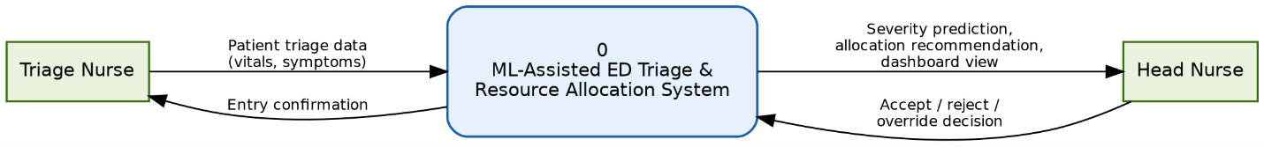
Figure 1Level 0 — Context Diagram

Level 1 Process Decomposition
The Level 1 diagram decomposes the system into its four core processes, corresponding directly to the functional requirements defined in Section 3.3.
Process 1.0 (Record Triage Data) captures the triage nurse's data entry and stores it in the Patient/Triage Records data store (D1). This stored record is read by Process 2.0 (Predict Severity), which applies the trained classification model to return an advisory acuity level.
The predicted severity is passed to Process 3.0 (Generate Allocation Recommendation), which combines it with the current state of the Room Status (D2) and Doctor Status (D3) data stores to produce a recommended room and doctor assignment, in line with FR-04. This recommendation is written to the Allocation Records data store (D4) before being surfaced to the Head Nurse through Process 4.0 (Manage Dashboard and Decisions), which implements the real-time dashboard (FR-06) and the accept/reject/override workflow (FR-05). Once a decision is confirmed, Process 4.0 writes back to all three data stores to keep room status, doctor status, and allocation records consistent with the confirmed outcome.
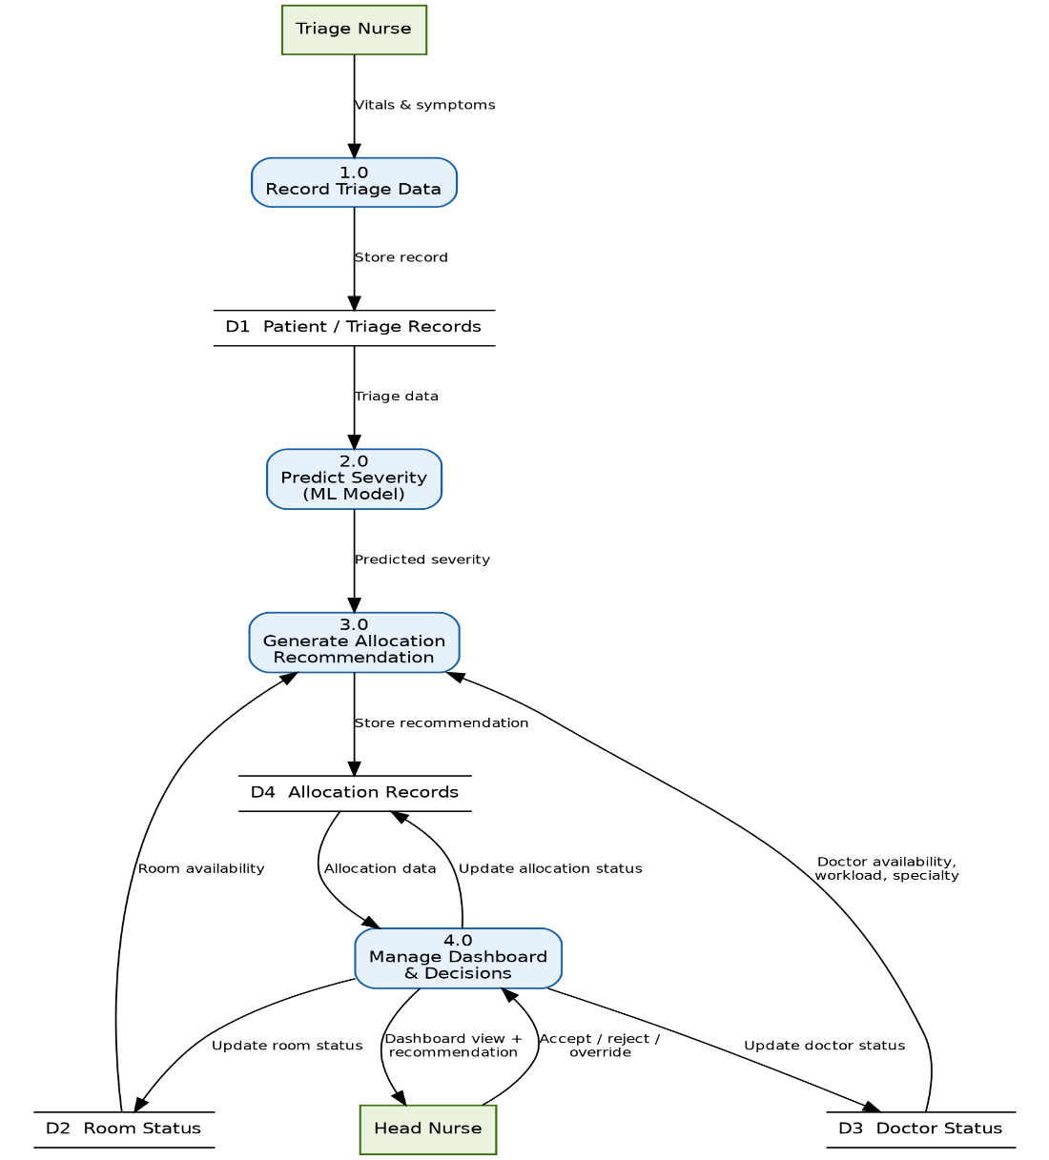
Figure 2 Level 1 Process Decomposition

4.2 Entity Relationship Diagram
The ERD defines six entities: User, Patient, TriageRecord, Room, Doctor, and Allocation.
A User (distinguished by a role field, either Triage Nurse or Head Nurse) can record many TriageRecords, and a Patient may have multiple TriageRecords over the course of their visit. Each TriageRecord can generate one or more Allocation entries modeled as a one-to-many relationship rather than one-to-one, to accommodate the possibility of a patient's priority being reassessed and reallocated if their condition changes. Each Allocation references exactly one Room and one Doctor, and is approved by a User acting in the Head Nurse role.
Allocation is modeled as its own entity rather than as additional columns on TriageRecord, since an allocation represents a distinct event (a resource-assignment decision at a point in time) that may recur independently of the triage record itself. Role-based permissions are represented as a single attribute on the User entity rather than separate tables for each role; role-specific access is enforced at the database level through PostgreSQL Row-Level Security policies (see NFR-03), keeping the schema simple.

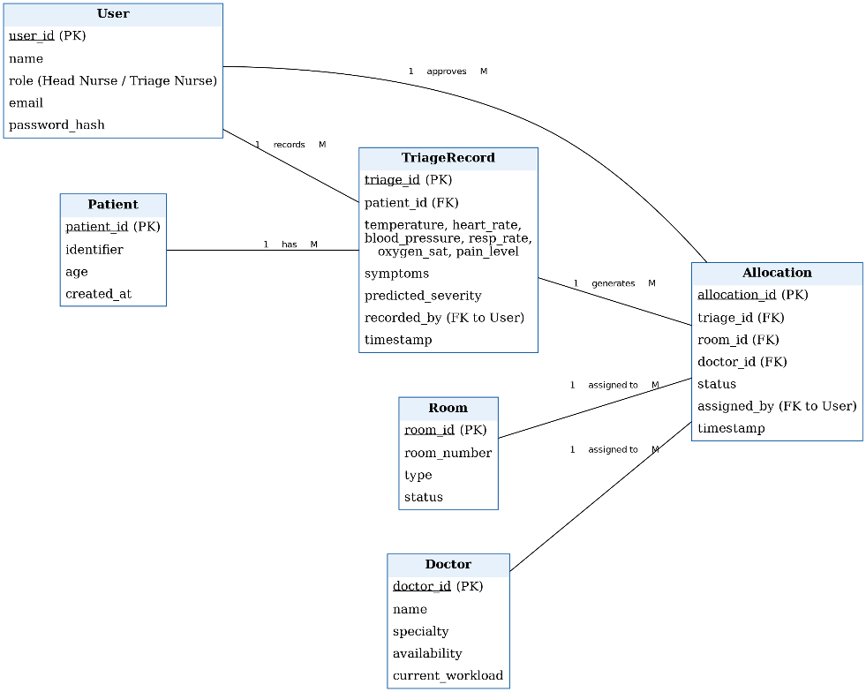
Figure 3 Entity Relationship Diagram

4.3 Proposed Timeline
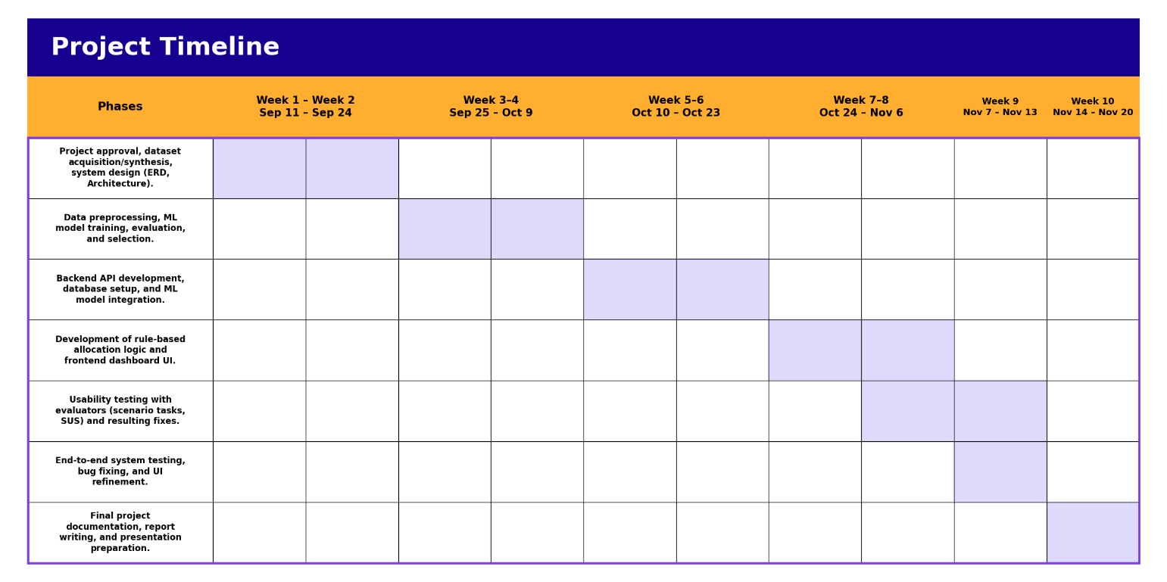
Figure 4 Project Timeline as a Gantt Chart

References
Ansermino, J. M., Pillay, Y., Tagoola, A., Zhang, C., Dunsmuir, D., Kamau, S., Kigo, J., Agaba, C., Aye, I. A., Hwang, B., Novakowski, S. K., Huxford, C., Wiens, M. O., Kimutai, D., Ouma, M., Ahmed, I., Mwaniki, P., Oyella, F., Tenywa, E., Nambuya, H., Toliva, B. O., Kenya-Mugisha, N., Kissoon, N., & Akech, S. (2025). Implementation of Smart Triage combined with a quality improvement program for children presenting to facilities in Kenya and Uganda: An interrupted time series analysis. PLOS Digital Health, 4(3), e0000466. https://doi.org/10.1371/journal.pdig.0000466
Hinson, J. S., Levin, S. R., Steinhart, B. D., Chmura, C., Sangal, R. B., Venkatesh, A. K., & Taylor, R. A. (2025). Enhancing emergency department triage equity with artificial intelligence: Outcomes from a multisite implementation. Annals of Emergency Medicine, 85(3), 288–290. https://doi.org/10.1016/j.annemergmed.2024.10.014
K'Oremo, L. A., Thigiti, J. M., & Were, F. O. (2026). Predictors of length of stay of patients at the emergency departments of Level 5 government hospitals in Nairobi City County, Kenya. Iconic Research and Engineering Journals, 10(2). https://doi.org/10.64388/IREV10I2-1722648
Levin, S., Toerper, M., Hamrock, E., Hinson, J. S., Barnes, S., Gardner, H., Dugas, A., Linton, B., Kirsch, T., & Kelen, G. (2018). Machine-Learning-Based Electronic Triage More Accurately Differentiates Patients With Respect to Clinical Outcomes Compared With the Emergency Severity Index. Annals of Emergency Medicine, 71(5), 565–574.e2. https://doi.org/10.1016/j.annemergmed.2017.08.005
Mashoka, R. J., Murray, B., George, U., Lobue, N., Mfinanga, J., Sawe, H., & White, L. (2019). Implementation of electronic medical records at an Emergency Medicine Department in Tanzania: The information technology perspective. African journal of emergency medicine : Revue africaine de la medecine d'urgence, 9(4), 165–171. https://doi.org/10.1016/j.afjem.2019.07.002
Ngaruiya, C., Tong, G., Mowafi, H., Hartz, L., Mulimba, B., Shah, M., Rayo, J., Nyayieka, I., & Wachira, B. (2026). Emergency care capacity and accessibility for non-communicable diseases in Kenyan EDs: A regional analysis [Preprint]. medRxiv. https://doi.org/10.64898/2026.02.23.26345636
Pienaar, M. A., Luwes, N., Sempa, J. B., George, E., & Brown, S. C. (2024). A validation of machine learning models for the identification of critically ill children presenting to the paediatric emergency room of a tertiary hospital in South Africa: A proof of concept. Southern African Journal of Critical Care, 40(3), e1398. https://doi.org/10.7196/sajcc.2024.v40i3.1398
Raita, Y., Goto, T., Faridi, M. K., Brown, D. F. M., Camargo, C. A., & Hasegawa, K. (2019). Emergency department triage prediction of clinical outcomes using machine learning models. Critical Care, 23, Article 64. https://doi.org/10.1186/s13054-019-2351-7
Rominski, S., Bell, S. A., Oduro, G., Ampong, P., Oteng, R., & Donkor, P. (2014). The implementation of the South African Triage Score (SATS) in an urban teaching hospital, Ghana. African Journal of Emergency Medicine, 4(2), 71–75. https://doi.org/10.1016/j.afjem.2013.11.001
Sitthiprawiat, P., Wittayachamnankul, B., Sirikul, W., & Laohavisudhi, K. (2025). Development and internal validation of an AI-based emergency triage model for predicting critical outcomes in emergency department. Scientific Reports, 15, Article 31212. https://doi.org/10.1038/s41598-025-17180-1
Wangara, A. A., Hunold, K. M., Leeper, S., Ndiawo, F., Mweu, J., Harty, S., Fuchs, R., Martin, I. B. K., Ekernas, K., Dunlop, S. J., Twomey, M., Maingi, A. W., & Myers, J. G. (2019). Implementation and performance of the South African Triage Scale at Kenyatta National Hospital in Nairobi, Kenya. International Journal of Emergency Medicine, 12(1), Article 5. https://doi.org/10.1186/s12245-019-0221-3

